

Faculty of engineering

Principle of Machine Course

***Team 3***

**24/03/2025 Monday**

**TABLE OF CONTENTS**

Glossary 8

1. INTRODUCTION 11

2. Comparative Analysis and Insights 39

3. CONCLUSION 40

4. REFERENCES 41

**TABLE OF FIGURES**

Figure 1 YOLOv3 architecture (YOLOv3 - NN Darknet-53 schematic) 12

Figure 2 Data collection setup at Centrale Station, Milan 13

Figure 3 The architecture of the proposed Hyper-pedestrian CNN (HP-CNN) 13

Figure 4 The architecture of the SE-Block used inside HP-CNN 14

Figure 5 Bounding boxes showing ID-based pedestrian tracking 14

Figure 6 trajectory path of one ID (Example of pedestrian trajectory over time) 14

Figure 7 Pedestrian images from the RAP dataset with detection and classification results by HP-CNN 15

Figure 8 mean speed & Voronoi density distribution (Density and speed distribution of pedestrians) 15

Figure 9 clustered directions and speeds (Clustering of pedestrian speeds and directions during morning and evening sessions). 16

Figure 10 Performance metrics showing detection limitations 17

Figure 11 Overview of the proposed P2CWS framework 18

Flowchart 12 Overall architecture of the vision framework used in the system 18

Figure 13 An example showcasing the extraction of 2D skeletal poses from video frames, serving as input for the SPI-Net model 19

Figure 14 depicts the Pedestrian Graph Network, where body joints are modeled as nodes, and their relationships are represented as edges processed by Graph Convolutional Networks (GCNs). 19

Figure 15 Data samples from the TUD and PCNC datasets 20

Figure 16 Example of estimated 2D and 3D pedestrian poses 21

Figure 17 Distribution of absolute errors and cumulative errors across angles 22

Figure 18 An illustration of the process of estimating 2D poses and constructing graphs for GCN input to predict pedestrian crossing behavior. 22

Figure 19 Examples of different attributes in the RAP dataset (e.g., clothing type, accessories, actions) 24

Figure 20 Examples of annotated viewpoints and occlusion patterns in the dataset 25

Figure 21 Attribute recognition accuracy on RAP 25

Figure 22 Viewpoint-based recognition results and qualitative examples 26

Figure 23 Overview of the HMR architecture: an input image is encoded and passed through a 3D regression model and an adversarial discriminator to predict pose and shape. 27

Figure 24 Overview of DirectPose architecture combining FPN, KPAlign, and multi-branch keypoint detection heads 28

Figure 25 Illustration of the KPAlign module showing how features are aligned and refined to predict keypoint coordinates. 28

Figure 26 Side-by-side comparison of regression-based and heatmap-based approaches for 2D pose estimation 29

Figure 27 VR setup where pedestrians walk on a treadmill, translated into a virtual crosswalk scene for better immersion. 31

Figure 28 Shows how the IRS metric works by comparing predicted and actual pedestrian presence in the ROI over time (TP, TN, FN marked). 32

Figure 29 Results of pedestrian trajectory data collection. 32

Figure 30 Most tracks are from course #1 (65%) and most crossings occur on the road (75%). 33

Figure 31 Gap acceptance in VR is similar to real-world data. Pedestrians walk faster on crosswalks than sidewalks. 33

Figure 32 The hybrid model shows lower average, final, and RMS errors than the constant velocity model. 34

Figure 33 Simulations show the fusion model reduces ADE and FDE 34

Figure 34 The full CVAE outperforms the motion-only model, especially for longer horizons (2–4s), based on IRS-related metrics. 34

Figure 35 Forecasts pedestrian locomotion by predicting both trajectory and pose key points from a vehicle's viewpoint. 35

Figure 36 An encoder-recurrent-decoder model forecasts global pedestrian motion using pose, depth, and egomotion features across frames. 36

Figure 37 A comparison between different forms of appearance information: (a) 2D image patch; (b) 3D point cloud; (c) 3D human keypoints inferred from (b). 36

Figure 38 An illustrative diagram of the proposed method, which has an encoder-decoder architecture. More specifically, there are two encoding branches to extract features from context and keypoints information respectively and multiple decoding heads for major tasks and auxiliary supervisions. 37

Figure 39 A diagram of the shuffled *Figure 40* A diagram of the auxiliary contrastive. 37

**THE TABLES**

Table 1 - Pedestrian attribute classification performance on RAP dataset 16

Table 2 - Body parts detection evaluation on RAP dataset 16

Table 3 17

Table 4 - Test results of pedestrian orientation recognition 21

Table 5 23

Table 6 23

Table 7 - Comparison between RAP and other pedestrian attribute datasets (e.g., PETA, GRID) 24

Table 8 - Annotations available in the RAP dataset (whole-body, accessories, actions, occlusions, parts) 25

Table 9 - Performance comparison on RAP and PETA datasets 26

Table 10 - 26

Table 11 - 27

Table 12 - Shows the improvement in APkp using KPAlign module versus baseline on COCO minival 29

Table 13 - Further ablation of KPAlign with grouped keypoints, separate features, and better sampling on COCO minival. 30

Table 14 - Comparison of DirectPose against top-down, bottom-up, and other end-to-end methods on COCO test-dev. 30

Table 15 30

Table 16 30

Table 17 33

Table 18 35

Table 19 38

Table 20 38

**Table 21 - Detection and Attribute Recognition vs. Pose Estimation Models** 39

**Table 22 - Hybrid Models vs. Deep Learning Behavioral Forecasting** 39

## Glossary

**YOLOv3 (You Only Look Once version 3)**

A fast and accurate real-time object detection algorithm based on a single neural network that divides images into grids and predicts bounding boxes and class probabilities directly.

**HP-CNN (Hyper-pedestrian Convolutional Neural Network)**

A multi-task learning model designed to perform both pedestrian body parts detection and attribute classification using multi-scale feature fusion and Squeeze-and-Excitation blocks.

**RAP Dataset (Richly Annotated Pedestrian Dataset)**

A large-scale pedestrian dataset with 41,585 annotated samples including 69 binary attributes such as gender, age, accessories, and occlusion patterns, collected from indoor surveillance settings.

**GCN (Graph Convolutional Network)**

A deep learning model that operates on graph-structured data, where nodes represent entities (e.g., body joints) and edges capture relationships, commonly used for spatio-temporal pattern recognition.

**P2CWS (Predictive Pedestrian Collision Warning System)**

An intelligent transportation system framework that predicts pedestrian crossing intentions using 3D pose estimation and provides real-time collision warnings to vehicles.

**SPI-Net (Skeleton Pose-based Intention Network)**

A dual-branch neural network designed to predict pedestrian crossing intentions based on 2D skeletal pose sequences, using both geometric and Cartesian representations.

**JAAD Dataset (Joint Attention in Autonomous Driving Dataset)**

A dataset containing videos of pedestrians interacting with traffic, annotated with bounding boxes, behavioral labels, and crossing intentions.

**TUD Dataset (Technical University of Darmstadt Pedestrian Dataset)**

A dataset consisting of pedestrian images in urban environments used primarily for pedestrian detection and tracking research.

**PCNC Dataset**

A dataset focused on pedestrian crossing behavior at non-signalized urban intersections.

**HMR (Human Mesh Recovery)**

A deep learning framework that predicts a full 3D mesh of the human body from a single RGB image by combining 3D regression with adversarial training.

**HRNet (High-Resolution Network)**

A pose estimation model that maintains high-resolution feature maps throughout the network by fusing multi-scale information at different layers.

**DirectPose**

An end-to-end anchor-free framework for multi-person pose estimation that aligns features directly to keypoints without requiring bounding boxes or heuristic grouping.

**mAP (mean Average Precision)**

A metric used to evaluate object detection models by calculating the average precision across all classes at various intersection-over-union (IoU) thresholds.

**PCK (Percentage of Correct Keypoints)**

A metric used in pose estimation to measure how many predicted keypoints fall within a threshold distance from the ground truth keypoints.

**ADE (Average Displacement Error)**

The average Euclidean distance between predicted and ground-truth trajectories over all time steps.

**FDE (Final Displacement Error)**

The Euclidean distance between the predicted final position of a trajectory and its ground-truth final position.

**IRS (Impact Risk Score)**

A custom metric designed to assess the safety of pedestrian path predictions by measuring the risk of pedestrian-vehicle conflict within a Region of Interest (ROI).

**CVAE (Conditional Variational Autoencoder)**

A generative deep learning model that learns latent representations conditioned on input variables, commonly used for trajectory prediction tasks.

**MSFF (Multi-Scale Feature Fusion)**

A technique used in deep learning models to combine feature maps from different scales, improving performance on tasks requiring fine-grained details.

**SE-Block (Squeeze-and-Excitation Block)**

A module that recalibrates feature maps by modeling interdependencies between channels to boost relevant features while suppressing less important ones.

**Kalman Filter**

A recursive filter algorithm used to estimate the state of a dynamic system from a series of noisy measurements.

**Markov Model**

A probabilistic model that describes a sequence of possible events where the probability of each event depends only on the state attained in the previous event.

**Quasi-RNN (Quasi-Recurrent Neural Network)**

A hybrid model combining recurrent neural network capabilities with convolutional layers to process sequential data efficiently.

**Contrastive Learning**

A self-supervised learning approach where the model learns to differentiate between similar and dissimilar pairs of data, often used to enhance representation learning.

## 1. INTRODUCTION

Machine learning plays a critical role in the development of autonomous vehicle systems, especially in understanding and predicting pedestrian behavior. This project focuses on applying machine learning principles to improve pedestrian detection, attribute recognition, and behavior forecasting to enhance road safety.

By exploring and comparing multiple state-of-the-art models—including real-time object detectors (e.g., YOLOv3), multi-task learning frameworks (e.g., HP-CNN), pose estimation techniques (e.g., GCNs and 3D models), and hybrid simulation-based systems—the project provides insights into how machine learning methods can be leveraged to build smarter and safer autonomous driving technologies.

SECTION 1 **- Pedestrian Detection + Attribute Recognition (YOLO + HP-CNN + RAP dataset)**

**1. Pedestrian Detection and Attribute Classification using Deep Learning Techniques**

* **Study Objective**:

to detects pedestrians in urban environments and classify their attributes (e.g., gender, clothing, body parts) by leveraging state-of-the-art deep learning models, including YOLOv3 for detection and Hyper-pedestrian CNN (HP-CNN) for multi-task classification.

* **Methodology**:

1. **YOLOv3 for Real-Time Pedestrian Detection:**
   * YOLOv3 with Darknet-53 backbone is applied for real-time pedestrian detection and tracking in video streams (Karagulian et al., 2023).
   * Used in an outdoor setting (e.g., Milan railway station) for generating bounding boxes and trajectories of pedestrians.
   * Voronoi-based density estimation is then applied to study flow and crowd behavior.

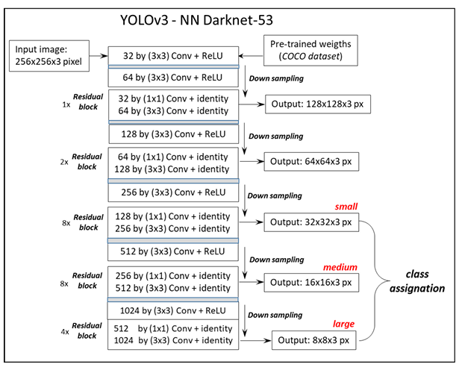

Figure 1 YOLOv3 architecture (YOLOv3 - NN Darknet-53 schematic)

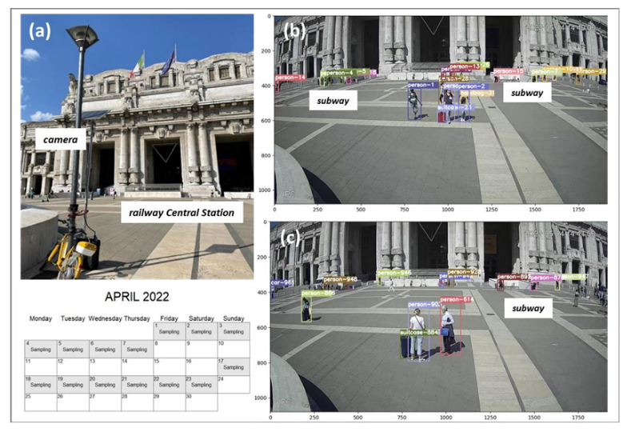

Figure 2 Data collection setup at Centrale Station, Milan

1. **Multi-task Learning using HP-CNN:**
   * HP-CNN incorporates multi-scale feature fusion (MSFF) and Squeeze-and-Excitation (SE) blocks to perform two tasks simultaneously:
2. Pedestrian body parts detection (e.g., head, upper body, lower body)
3. Multi-attribute classification (e.g., gender, accessories)
   * The architecture fuses feature at multiple levels to boost performance on fine-grained pedestrian classification tasks.
   * MSFF combines features from these multiple layers so the network can simultaneously "see" both small/local details and large/global patterns

MSFF helps the network gather multi-scale information.

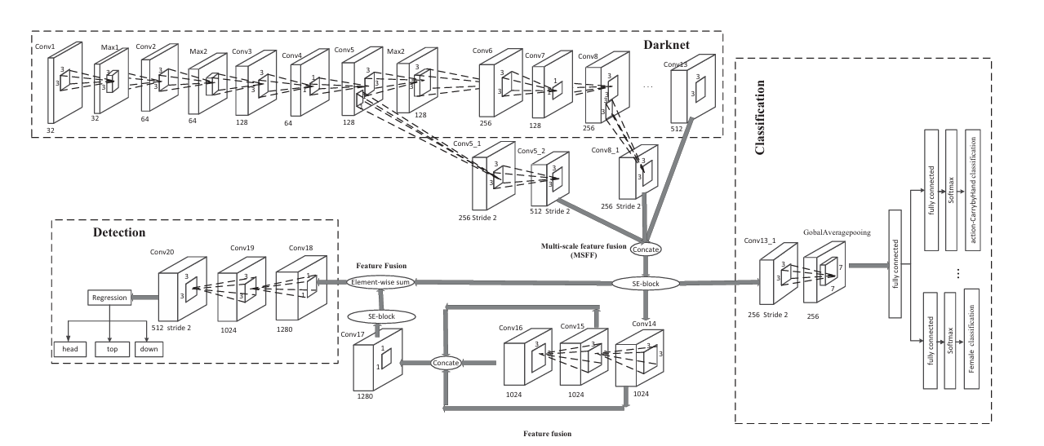

Figure 3 The architecture of the proposed Hyper-pedestrian CNN (HP-CNN)

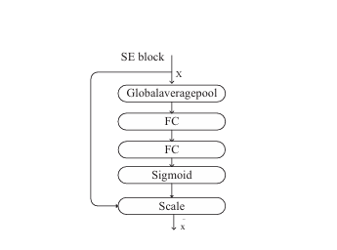

Figure 4 The architecture of the SE-Block used inside HP-CNN

SE-Blocks help the network prioritize which channels/features are most important after fusion.

* **Data**:
  + **YOLOv3 study**: Outdoor video recordings from Milan Centrale Station (Karagulian et al.

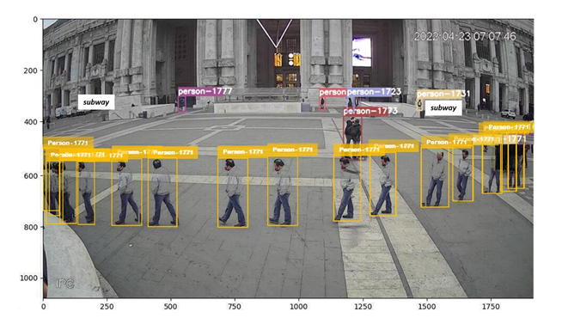

Figure 5 Bounding boxes showing ID-based pedestrian tracking

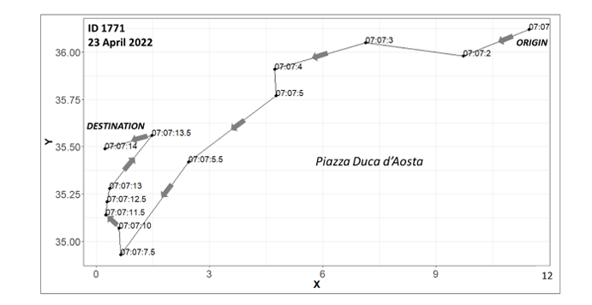

Figure 6 trajectory path of one ID (Example of pedestrian trajectory over time)

* + **HP-CNN study**: Indoor images from the RAP dataset with 41,585 annotated samples (Lou et al.).

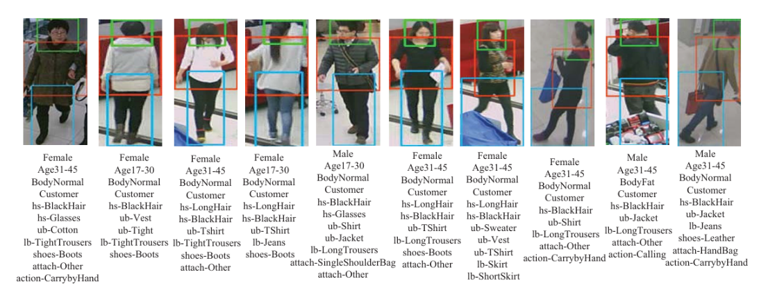

Figure 7 Pedestrian images from the RAP dataset with detection and classification results by HP-CNN

* **Results**:
  + **YOLOv3 Findings**:
* Achieved real-time detection with crowd-level metrics (density ~0.035 people/m², speed clusters 0.77 m/s and 0.65 m/s).
* Noted challenges with small object detection and occlusion handling in dense crowds.

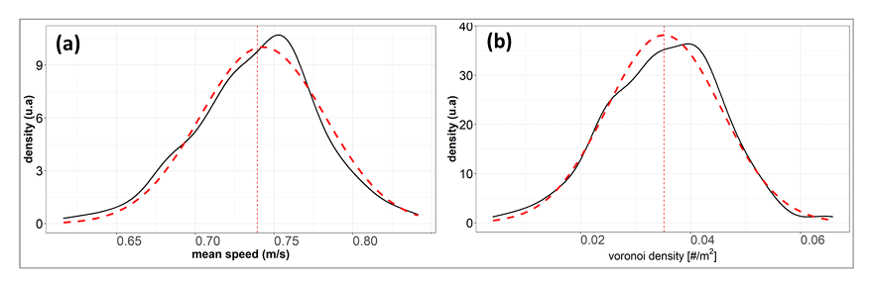

Figure 8 mean speed & Voronoi density distribution (Density and speed distribution of pedestrians)

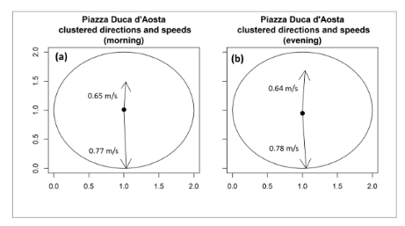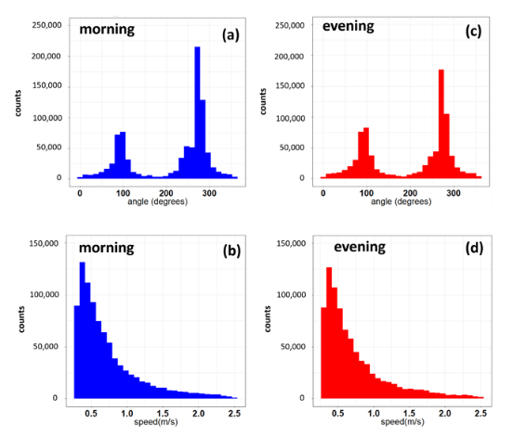

Figure 9 clustered directions and speeds (Clustering of pedestrian speeds and directions during morning and evening sessions).

* + **HP-CNN Findings**:
* Attribute classification: 65.87% accuracy, 82.51% precision, and F1-score of 78.46%.
* Body parts detection: mAP of 97.88% on RAP dataset.
* Outperformed baseline models like DeepMAR and PGDM-Fusion.

Table 1 - Pedestrian attribute classification performance on RAP dataset

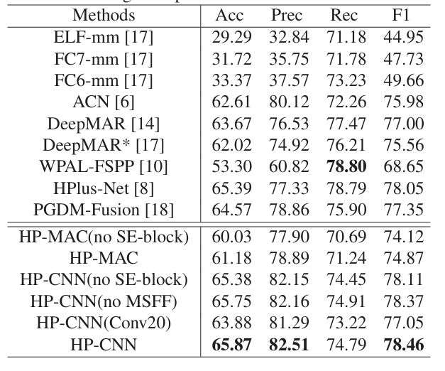

* + In body parts detection, HP-CNN achieved a mean average precision (mAP) of 97.88% across the head, top, and lower body (Table 2).

Table 2 - Body parts detection evaluation on RAP dataset

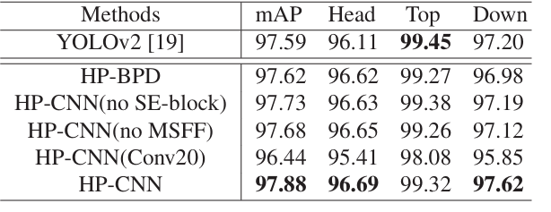

* **Limitations**:

Table 3

|  |  |
| --- | --- |
| **HP-CNN** | YOLOv3 |
| Higher computational cost due to MSFF & SE-blocks | Struggles with occlusions & small pedestrians |
| More demanding training time and inference latency | Detection performance drops in crowded environments |



Figure 10 Performance metrics showing detection limitations

**SECTION 2 - Intention Prediction & ITS using Pose Estimation (3D / 2D skeletal + GCN)**

**2. Pedestrian Intention Prediction and ITS Applications using 3D Pose Estimation**

* **Study Objective**:

To develop intelligent transportation systems (ITS) capable of predicting pedestrian crossing intentions and preventing collisions by utilizing advanced 3D pose estimation and spatio-temporal modeling.

* **Methodology**:

**A. Real-Time Predictive Pedestrian Collision Warning Service (P2CWS):**

* + A roadside vision-based system predicts pedestrian crossing intentions in real-time (Kim et al.).
  + Combines CCTV feeds, 3D pose estimation, and vehicle data from On-Board Units (OBUs).
  + Uses pose vectors, pedestrian orientation, and environmental context (crosswalk position, vehicle proximity) to trigger warnings for nearby vehicles.

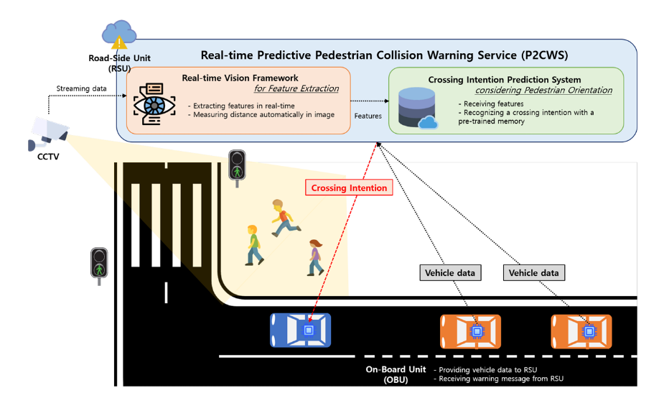

Figure 11 Overview of the proposed P2CWS framework

* **Vision Framework (FLOWCHART 1)**
  + Object detection and pedestrian tracking.
  + Human 3D pose estimation and orientation calculation.
  + Prediction of crossing intentions using pedestrian, vehicle, and environmental features.

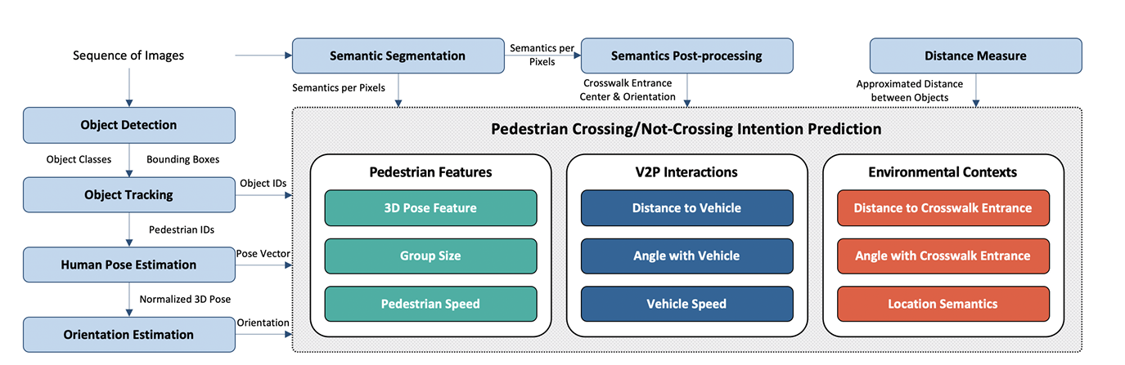

Flowchart 12 Overall architecture of the vision framework used in the system

**B. SPI-Net Model for Intention Prediction:**

* + SPI-Net predicts crossing intentions using 2D skeletal pose sequences extracted from video frames:
  + Consists of two branches:
    1. **Cartesian branch**: processes joint coordinates over time.
    2. **Geometric branch**: focuses on angles and distances between joints.

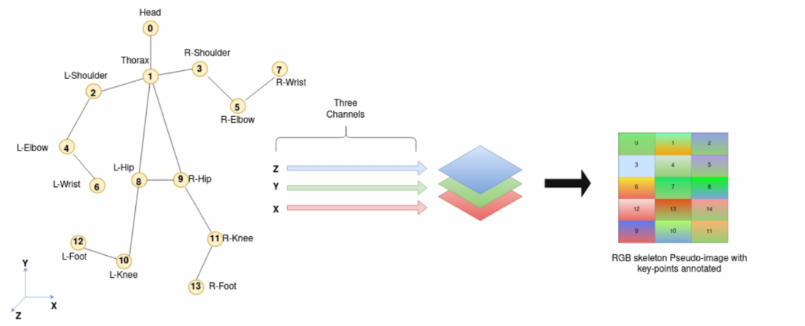

Figure 13 An example showcasing the extraction of 2D skeletal poses from video frames, serving as input for the SPI-Net model

1. **Pedestrian Graph Network (GCN-based):**
   * Graph Convolutional Network (GCN) models pedestrian pose as a graph of 14 joints, treating them as nodes with edges representing joint relationships.
   * Focuses on learning spatio-temporal pose dynamics to classify crossing vs. not-crossing behavior.

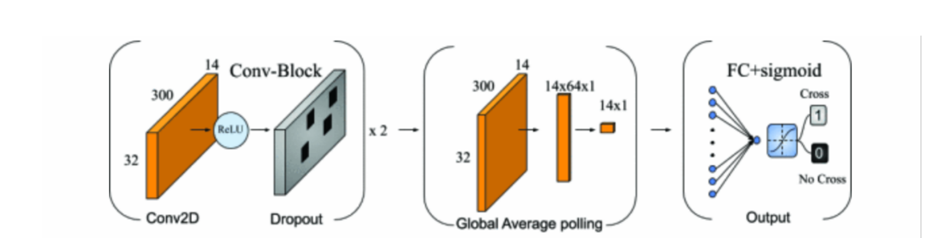

Figure 14 depicts the Pedestrian Graph Network, where body joints are modeled as nodes, and their relationships are represented as edges processed by Graph Convolutional Networks (GCNs).

* **Data**:
  + **P2CWS:** TUD and PCNC datasets (for real-world intersections and pedestrian images).

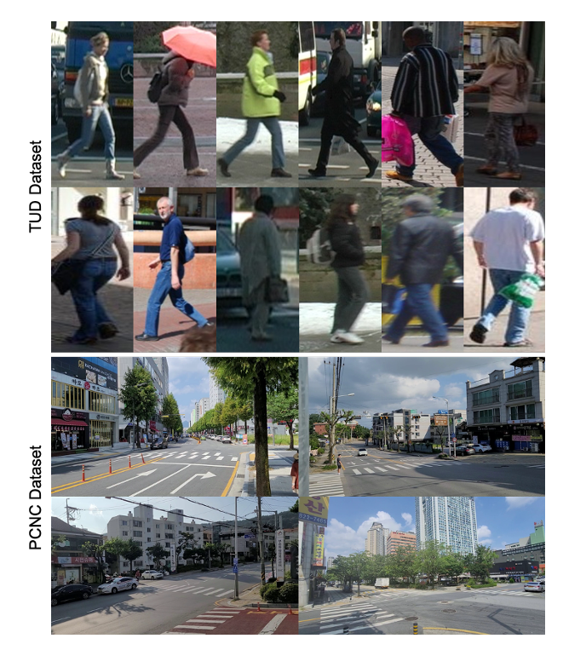

Figure 15 Data samples from the TUD and PCNC datasets

* + **SPI-Net & Pedestrian Graph**: JAAD dataset (pedestrian intention and crossing behavior).
* **Results**:
  + All methods showed strong results in predicting pedestrian crossing intentions.
  + P2CWS provided integrated collision warning feedback to vehicles in ITS setups.

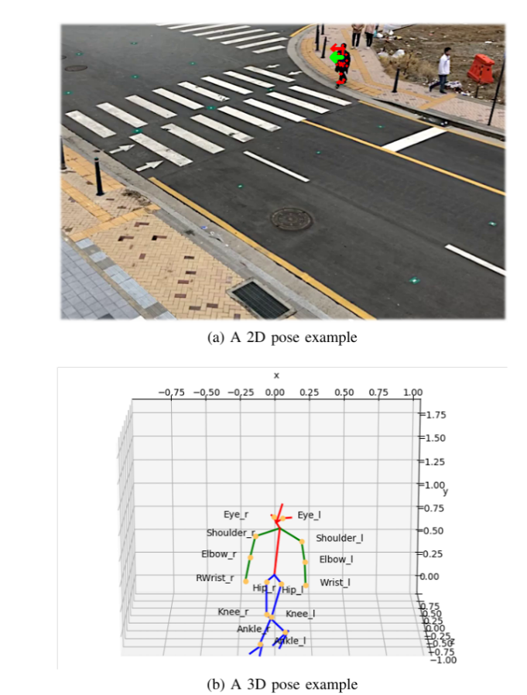

Figure 16 Example of estimated 2D and 3D pedestrian poses

**Orientation recognition accuracy:**

Achieved **89.3%** accuracy at **45°** orientation, outperforming several traditional methods (Table 3).

Table 4 - Test results of pedestrian orientation recognition

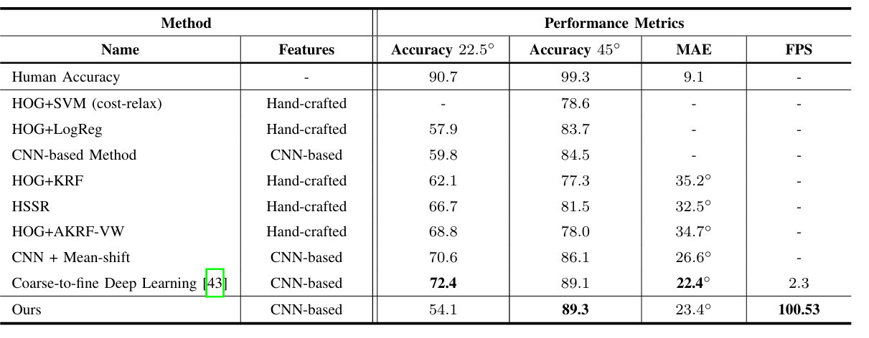

**Error Analysis:**

The distribution of absolute errors showed a left-skewed pattern, while cumulative errors were evenly distributed across angles (Figure 14).

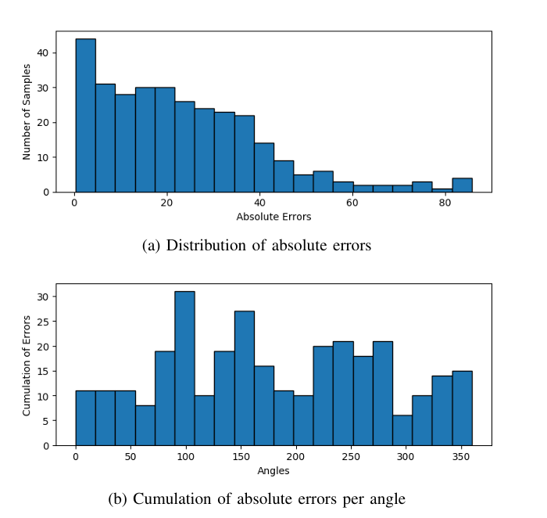

Figure 17 Distribution of absolute errors and cumulative errors across angles

* + SPI-Net focused on lightweight real-time prediction, while Pedestrian Graph captured deeper pose patterns.

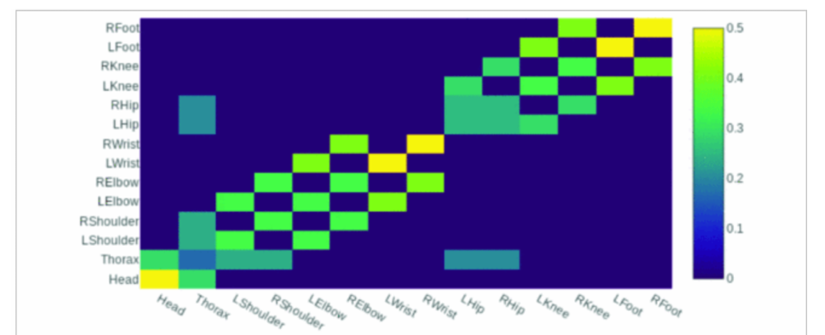

Figure 18 An illustration of the process of estimating 2D poses and constructing graphs for GCN input to predict pedestrian crossing behavior.

Table 5

|  |  |  |
| --- | --- | --- |
| **Model** | **Accuracy** | **FPS / Real-time Suitability** |
| P2CWS (3D + ITS) | 89.3% pedestrian orientation accuracy | Real-time (100+ FPS) at RSU and OBU |
| SPI-Net | 94.4% pedestrian intention prediction | Ultra-fast (4000+ FPS on GPU) |
| Pedestrian Graph (GCN) | 91.94% crossing prediction accuracy | Moderate real-time performance |

* **Limitations**:

Table 6

|  |  |  |
| --- | --- | --- |
| **Pedestrian Graph** | **SPI-Net** | **P2CWS** |
| No context-awareness (e.g., traffic lights) | Depends on external 2D pose estimator | Sensitive to crowded scenes and occlusions |
| Susceptible to pose detection noise | Doesn’t handle multiple pedestrians well | Needs integration with ITS infrastructure |

**SECTION 3 - Advanced Pose Estimation (General-purpose Pose Models)**

**3. Pedestrian Attribute Recognition using Multi-Task Models and Richly Annotated Datasets**

* **Objective**:

To improve pedestrian attribute recognition (e.g., gender, clothing, accessories) by leveraging multi-task deep learning models and using large-scale, richly annotated datasets like RAP.

* **Methodology**:

**A. HP-CNN Multi-task Learning Framework (Lou et al.):**

* + A deep neural network with two main tasks:
    1. Pedestrian body part detection (e.g., head, upper body, lower body).
    2. Multi-attribute classification (e.g., gender, age, carried objects).
  + The model integrates:
    1. Multi-Scale Feature Fusion (MSFF)
    2. Squeeze-and-Excitation (SE) blocks to enhance feature recalibration.

**B. RAP Dataset Contribution (Li et al.):**

* + RAP is one of the largest pedestrian attribute datasets with:
  + 41,585 annotated samples:
  + 69 binary attributes (e.g., backpack, carrying, gender, occlusions, part-based segmentation).
  + Spatial-temporal annotations and occlusion patterns.

**C. Attribute and Part-based Annotations:**

* + Annotations include:
  + Part-level segmentation: head-shoulder, upper body, lower body.
  + Occlusion labels and viewpoint distributions.

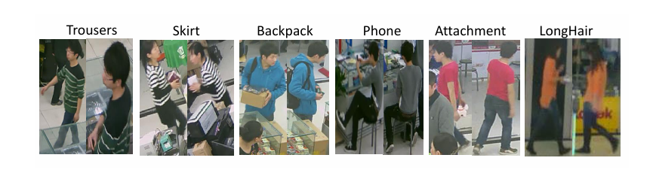

Figure 19 Examples of different attributes in the RAP dataset (e.g., clothing type, accessories, actions)

Table 7 - Comparison between RAP and other pedestrian attribute datasets (e.g., PETA, GRID)

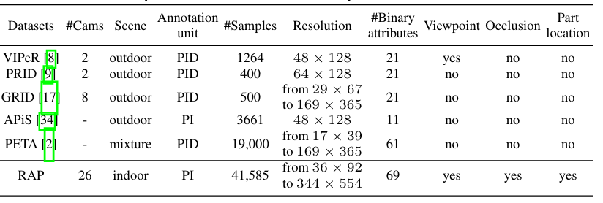

Table 8 - Annotations available in the RAP dataset (whole-body, accessories, actions, occlusions, parts)

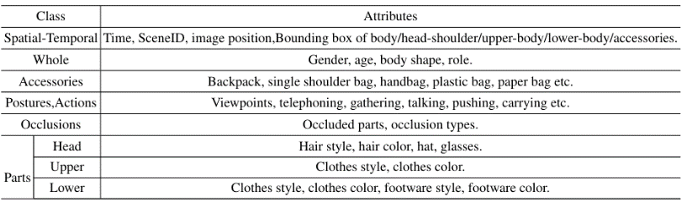

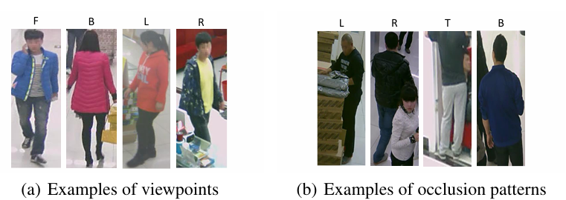

Figure 20 Examples of annotated viewpoints and occlusion patterns in the dataset

* **Data**:
  + **RAP dataset:** indoor surveillance images with varied pedestrian appearances.
  + **Additional datasets used in benchmarks:** PETA, GRID, VIPeR.)
* **Results**:
  + HP-CNN outperformed baseline methods like DeepMAR and PGDM-Fusion,High accuracy on attributes like "backpack" and "female" (Figure 17).



Figure 21 Attribute recognition accuracy on RAP

Performance drops in challenging conditions such as occlusion and extreme viewpoints (Figure 18).

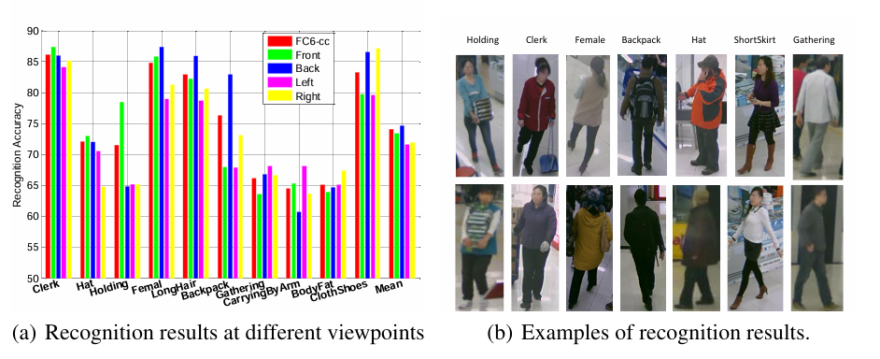

Figure 22 Viewpoint-based recognition results and qualitative examples

DeepMAR outperformed other methods with a mean accuracy of 73.79% on RAP and 75.07% on PETA datasets (Table 9).

Table 9 - Performance comparison on RAP and PETA datasets

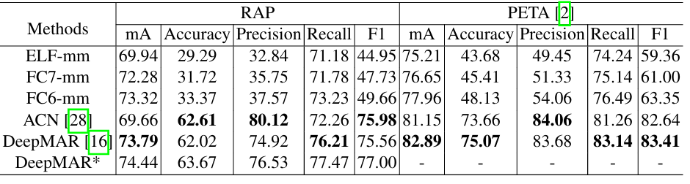

* + RAP dataset enabled more accurate recognition on challenging attributes (e.g., backpack, hat) and under occlusions.
  + Attribute recognition varies based on pedestrian viewpoint (front, back, side).

|  |  |  |  |  |  |
| --- | --- | --- | --- | --- | --- |
| **Model** | **Dataset** | **Accuracy** | **Precision** | **Recall** | **F1-Score** |
| HP-CNN | RAP | 65.87% | 82.51% | 74.79% | 78.46% |
| DeepMAR | RAP | 63.67% | 76.53% | 77.47% | 77.00% |

Table 10 -

* **Limitations**:

Table 11 -

|  |  |
| --- | --- |
| **HP-CNN** | **RAP DATASET** |
| Higher computational cost due to SE-blocks and MSFF | Mostly indoor data with fixed camera setups |
| Requires powerful hardware for training and inference | Limited outdoor or highly dynamic scenes |

**SECTION 4 - Hybrid and Simulation-Based Behavior Prediction**

**4. Advanced 2D/3D Human Pose Estimation Models**

* **Objective**:

To review and present advanced deep learning frameworks for human pose estimation, focusing on both 2D and 3D pose recovery from images, with potential applications in pedestrian behavior analysis and autonomous systems.

* **Methodology**:

**A. HMR - End-to-End Recovery of Human Shape and Pose (2018):**

* + Recovers full 3D mesh of the human body from a single RGB image:
    1. A 3D regression model.
    2. Adversarial discriminator (GAN) to ensure plausible pose and shape predictions.
    3. Trained with weak supervision using 2D keypoints when 3D ground-truth is unavailable.

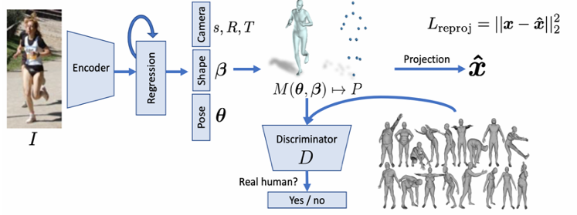

Figure 23 Overview of the HMR architecture: an input image is encoded and passed through a 3D regression model and an adversarial discriminator to predict pose and shape.

**B. HRNet (Sun et al.)**

* + Maintains high-resolution feature maps across the network to improve keypoint localization accuracy.
  + Employs multi-scale feature fusion at each stage via parallel branches.
  + Fuses high-to-low and low-to-high resolution features consistently.

**C. DirectPose Framework:**

* + End-to-end anchor-free keypoint detection framework.
  + Eliminates heuristic grouping (no bounding boxes needed).
  + Introduces KPAlign module for precise keypoint alignment with convolutional features.

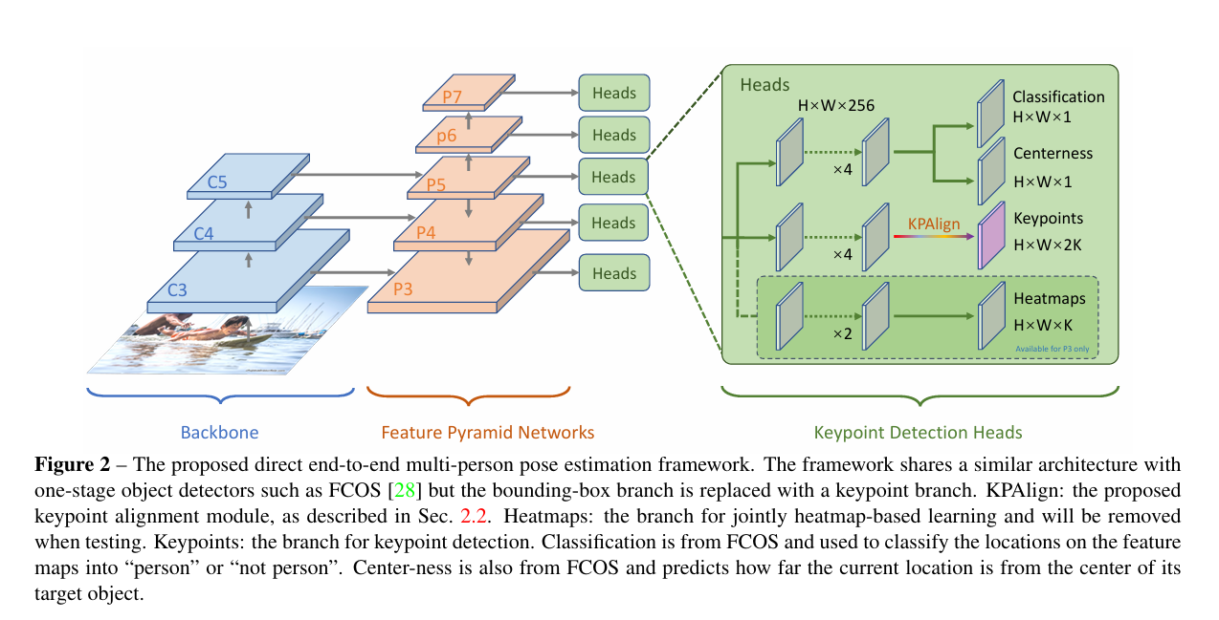

Figure 24 Overview of DirectPose architecture combining FPN, KPAlign, and multi-branch keypoint detection heads

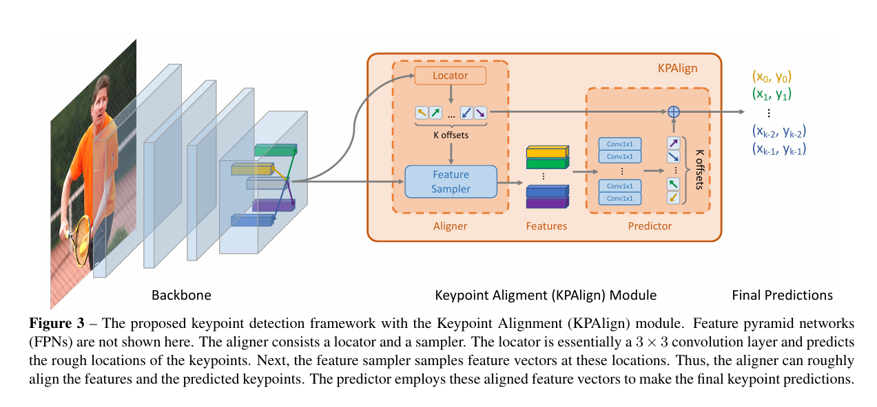

Figure 25 Illustration of the KPAlign module showing how features are aligned and refined to predict keypoint coordinates.

1. **Pose Estimation Survey (2023):**
   * Reviews over 260 papers on pose estimation, categorized into:
     1. Regression-based methods.
     2. Heatmap-based methods.
     3. Transformer-based models.
     4. Provides comparative analysis across popular benchmarks like COCO, Human3.6M, and MPII.

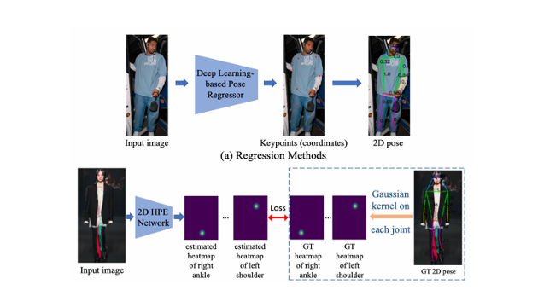

Figure 26 Side-by-side comparison of regression-based and heatmap-based approaches for 2D pose estimation

* **Data**:
  + **HMR**: Human3.6M, MPII, LSP datasets.
  + **HRNet**: COCO, MPII.
  + **DirectPose**: COCO dataset (250K+ instances).
* **Results**:

Table 12 - Shows the improvement in APkp using KPAlign module versus baseline on COCO minival

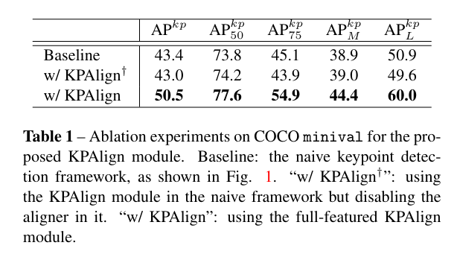

Table 13 - Further ablation of KPAlign with grouped keypoints, separate features, and better sampling on COCO minival.

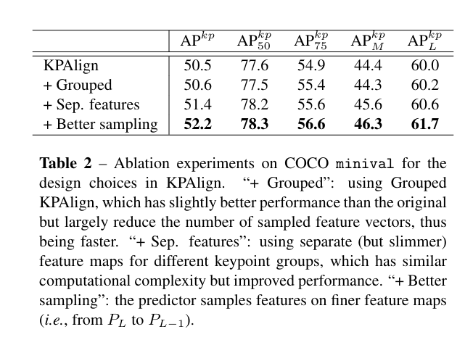

Table 14 - Comparison of DirectPose against top-down, bottom-up, and other end-to-end methods on COCO test-dev.

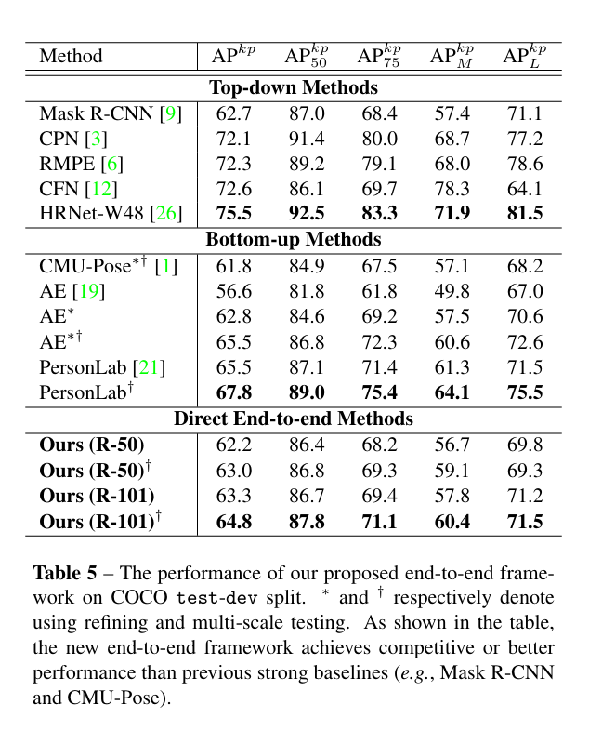

|  |  |  |
| --- | --- | --- |
| **Model** | **Dataset** | **FPS / Real-time Suitability** |
| HMR | Human3.6M | Competitive accuracy on 3D pose recovery; visually realistic meshes. |
| HRNET | MPII, COCO | AP = 92.3% on MPII validation set; outperforms SimpleBaseline and CPN. |
| DIRECTPOSE | COCO | Achieves 63.3% AP on COCO minival (ResNet-101 backbone). |
| **SURVEY** | Multiple | Shows trend toward multi-modal fusion and temporal modeling for pose estimation. |

Table 15

* **Limitations**:

|  |  |
| --- | --- |
| **Model** | **Limitation** |
| HMR | Sensitive to occlusions and unseen poses; no temporal modeling. |
| HRNET | Computationally expensive at higher resolutions. |
| DIRECTPOSE | Variance in crowded scenes; lower performance on small objects. |
| **SURVEY** | Provides overview but lacks experimental contributions. |

Table 16

**SECTION 5 - Miscellaneous Hybrid Models (Behavioral modeling with Markov + Physics-based approaches)**

**5. Pedestrian Behavior Prediction using Hybrid and Simulation-Based Models**

* **Objective**:

To improve long-term pedestrian crossing behavior prediction by combining simulation environments (e.g., VR) and hybrid machine learning models such as SVMs, Kalman filters, and Markov models.

* **Methodology**:

**A. VR-based Pedestrian Crossing Behavior Prediction (Schneemann et al.):**

* + Developed a hybrid system combining:
    1. Discrete state transitions (approach, wait, cross, walk away).
    2. Continuous motion dynamics using constant velocity models and Kalman filters.
    3. SVM classifier for "gap acceptance" prediction (i.e., whether pedestrians decide to cross based on vehicle proximity).

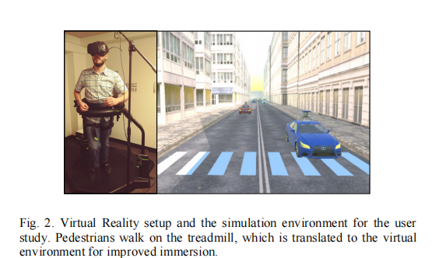

Figure 27 VR setup where pedestrians walk on a treadmill, translated into a virtual crosswalk scene for better immersion.

**B. Markov + Social Force Fusion Model:**

* + Combines a Markov model with a social force model for pedestrian path prediction.
  + Uses lateral planning (via potential fields) and longitudinal braking (fuzzy control).
  + Data is fed from unsignalized road scenarios.

**C. CVAE-based Pedestrian Path Prediction with IRS Metric (Keller et al.):**

* + Introduced a Conditional Variational Autoencoder (CVAE) model for pedestrian path prediction.
  + Proposed a new evaluation metric, IRS (Impact Risk Score), to assess prediction safety within autonomous vehicle environments.
  + Conducted an ablation study using traditional metrics (ADE, NLL) alongside IRS.

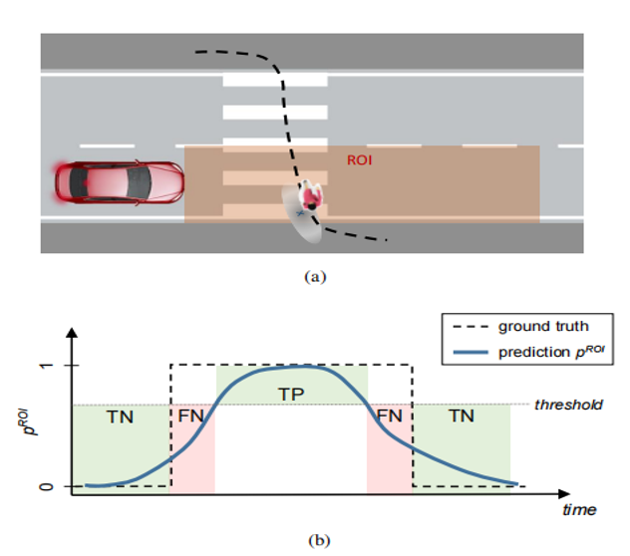

Figure 28 Shows how the IRS metric works by comparing predicted and actual pedestrian presence in the ROI over time (TP, TN, FN marked).

* **Data**:
  + **VR-based system**: Data from 30 participants and 540 crossings in a virtual mid-block crosswalk.
  + **Markov + Social model**: Pedestrian data collected from real unsignalized road scenarios using HOG, SVM, and Kalman filters

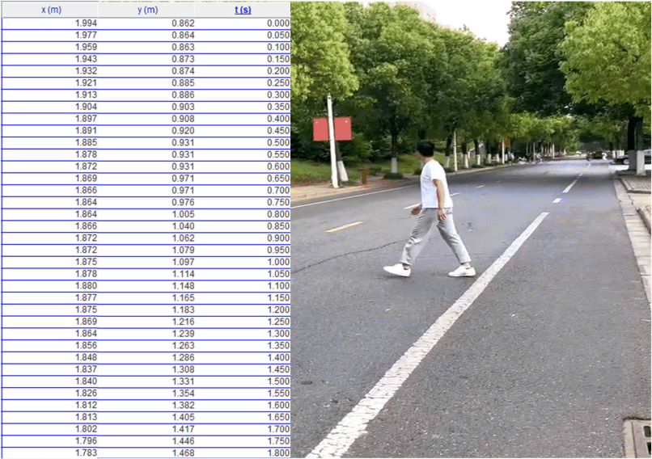

Figure 29 Results of pedestrian trajectory data collection.

* + **CVAE + IRS system**: German dataset with 93,000+ pedestrian tracks and detailed semantic maps.

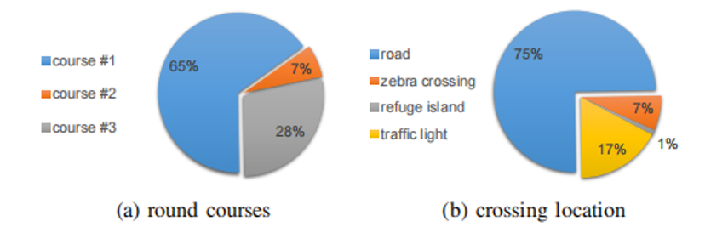

Figure 30 Most tracks are from course #1 (65%) and most crossings occur on the road (75%).

* **Results**:

|  |  |  |
| --- | --- | --- |
| **Model** | **Scenario** | **Results** |
| |  | | --- | | VR-based hybrid system |  |  | | --- | |  | | |  | | --- | | Virtual crosswalk |  |  | | --- | |  | | |  | | --- | | Accurate long-term crossing prediction beyond 5s horizon. |  |  | | --- | |  | |
| |  | | --- | | Markov + Social Force fusion |  |  | | --- | |  | | |  | | --- | | Unsignalized roads |  |  | | --- | |  | | |  | | --- | | Reduced average displacement error (ADE) and final displacement error (FDE) compared to single models. |  |  | | --- | |  | |
| |  | | --- | | CVAE with IRS metric |  |  | | --- | |  | | |  | | --- | | Urban AV environment |  |  | | --- | |  | | CVAE outperformed motion-only models, especially for longer-term predictions (2-4s horizon). IRS revealed deeper safety insights than traditional metrics. |

Table 17

Vr

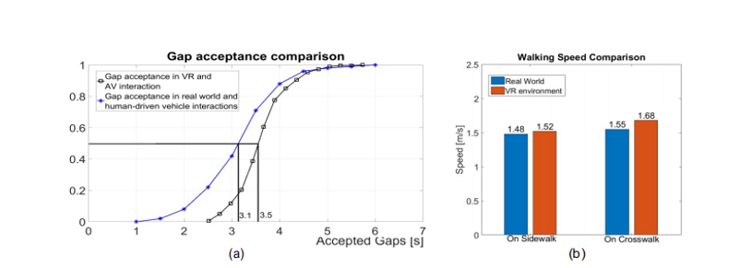

Figure 31 Gap acceptance in VR is similar to real-world data. Pedestrians walk faster on crosswalks than sidewalks.

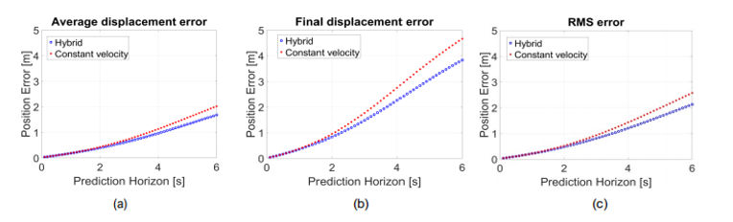

Figure 32 The hybrid model shows lower average, final, and RMS errors than the constant velocity model.

Makov

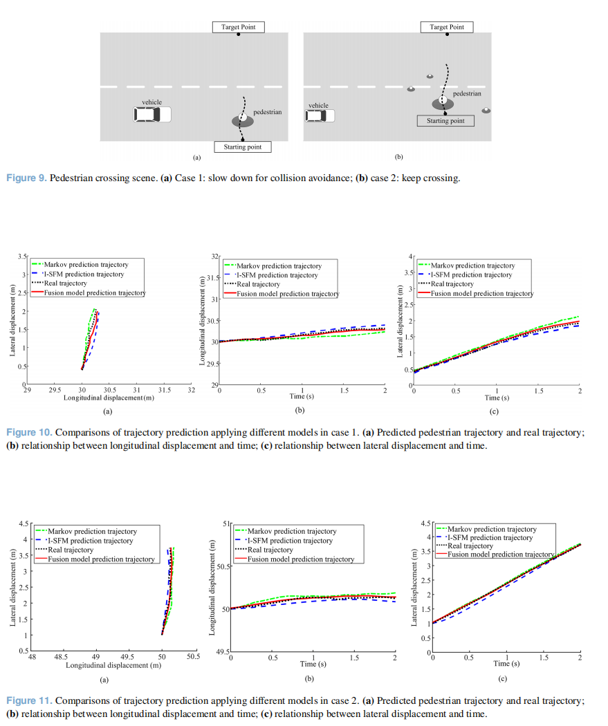

Figure 33 Simulations show the fusion model reduces ADE and FDE

Cvae

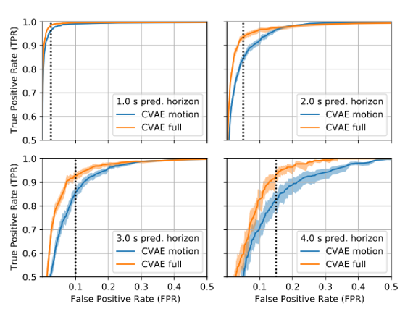

Figure 34 The full CVAE outperforms the motion-only model, especially for longer horizons (2–4s), based on IRS-related metrics.

* **Limitations**:

|  |  |
| --- | --- |
| **Model** | **Limitation** |
| |  | | --- | | VR-based system |  |  | | --- | |  | | |  | | --- | | Focused on individual pedestrians; virtual environment may not capture all real-world dynamics. |  |  | | --- | |  | |
| |  | | --- | | Markov + Social Force model |  |  | | --- | |  | | |  | | --- | | Limited to unsignalized roads; sensitive to parameter calibration. |  |  | | --- | |  | |
| |  | | --- | | CVAE + IRS system |  |  | | --- | |  | | Germany-specific dataset; no multi-agent interaction modeling |

Table 18

**SECTION 6 - Specialized Deep Learning Studies (Trajectory & Action)**

**6. Specialized Deep Learning Approaches for Pedestrian Trajectory and Action Prediction**

* **Objective**:

To enhance pedestrian trajectory forecasting and action recognition by using advanced deep learning models based on 3D keypoints, multi-task learning, and contrastive learning techniques.

* **Methodology**:

**A. Disentangling Human Dynamics for Locomotion Forecasting (Fang et al.):**

* + A novel model that splits pedestrian motion into two streams:
    1. **Global stream** for predicting the trajectory (global motion).
    2. **Local stream** for forecasting pose keypoints (local motion).
  + Utilizes a Quasi-RNN architecture with additional visual cues to boost robustness.
  + Handles noisy pose data via a pose completion module.

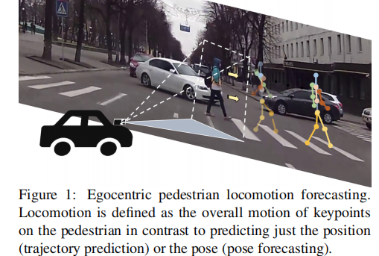

Figure 35 Forecasts pedestrian locomotion by predicting both trajectory and pose key points from a vehicle's viewpoint.

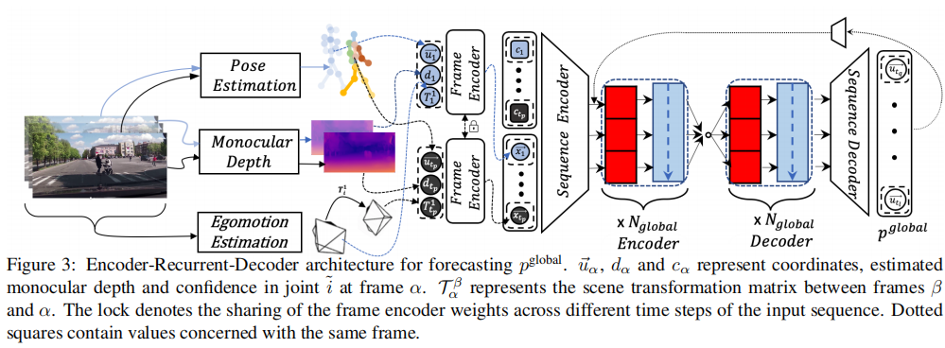

Figure 36 An encoder-recurrent-decoder model forecasts global pedestrian motion using pose, depth, and egomotion features across frames.

**B. Pedestrian Trajectory Prediction with 3D Keypoints (Li et al.):**

* + Uses a multi-task learning framework that combines:
    1. **3D keypoints from LiDAR**.
    2. **Auxiliary tasks** such as keypoint puzzles, jigsaw puzzles, and contrastive learning.
    3. Focuses on improving crossing action recognition and precise trajectory prediction.

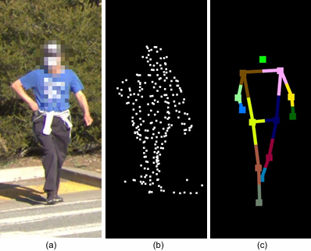

Figure 37 A comparison between different forms of appearance information: (a) 2D image patch; (b) 3D point cloud; (c) 3D human keypoints inferred from (b).

**C. Pedestrian Action Recognition using 3D Human Keypoints**

* + Proposes a contrastive learning approach integrated with 3D human keypoints.
  + Multi-task learning setup:
    1. Crossing action classification.
    2. Trajectory prediction (minADE / minFDE).
    3. Auxiliary contrastive losses to refine temporal understanding of motion patterns.

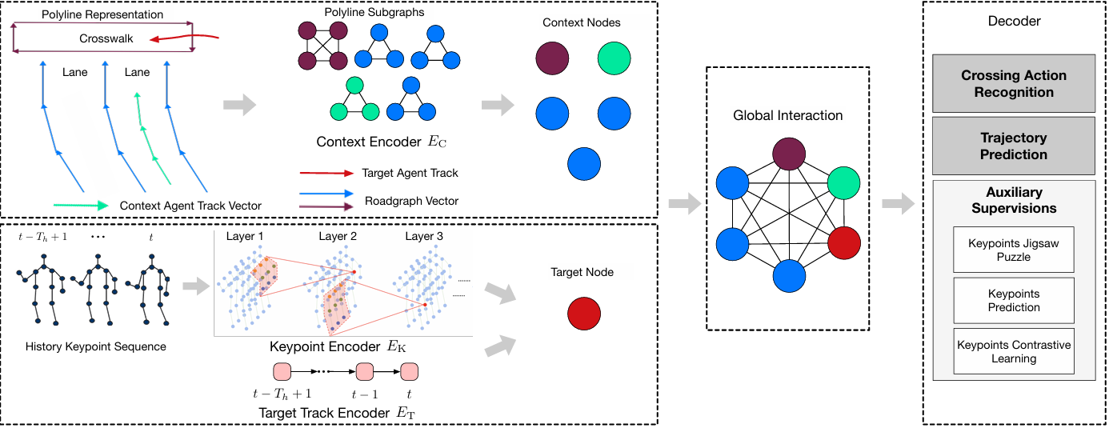

Figure 38 An illustrative diagram of the proposed method, which has an encoder-decoder architecture. More specifically, there are two encoding branches to extract features from context and keypoints information respectively and multiple decoding heads for major tasks and auxiliary supervisions.

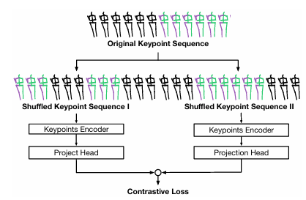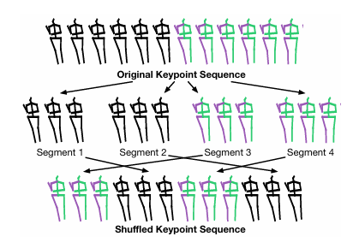

Figure 39 A diagram of the shuffled *Figure 40* A diagram of the auxiliary contrastive.

sequence generation process learning task leveraging the shuffled sequences in

* **Data**:
  + **In-house dataset** with over 2 million training samples (LiDAR + keypoints + road context).
  + **Waymo Open Dataset:** large-scale dataset with 3D point clouds and annotated pedestrian trajectories.
* **Results**:

|  |  |  |
| --- | --- | --- |
| **Model** | **dataset** | **Results** |
| |  | | --- | | **Disentangling Human Dynamics** |  |  | | --- | |  | | |  |  | | --- | --- | | |  | | --- | | JAAD dataset | | | |  |  | | --- | --- | | |  | | --- | | Outperformed LSTM & SRNN in KDE metrics. | |  |  | | --- | |  | |
| |  |  | | --- | --- | | |  | | --- | | **3D Keypoints Multi-task Framework** | |  |  | | --- | |  | | |  |  | | --- | --- | | |  | | --- | | In-house + Waymo | |  |  | | --- | |  | | |  |  | | --- | --- | | |  | | --- | | 98% accuracy in crossing recognition, minADE = 0.373, minFDE = 0.638. | |  |  | | --- | |  | |
| |  |  | | --- | --- | | |  | | --- | | **Contrastive Learning Framework** | |  |  | | --- | |  | | |  |  | | --- | --- | | |  | | --- | | In-house dataset | |  |  | | --- | |  | | Improved generalization under occlusion and motion variation. |

Table 19

* **Limitations**:

|  |  |
| --- | --- |
| **Model** | **Limitation** |
| |  |  | | --- | --- | | |  | | --- | | **Disentangling Human Dynamics** | |  |  | | --- | |  | | |  |  | | --- | --- | | |  | | --- | | Still sensitive to noisy supervision labels. | |  |  | | --- | |  | |
| |  |  | | --- | --- | | |  | | --- | | **3D Keypoints Multi-task Framework** | |  |  | | --- | |  | | |  |  |  | | --- | --- | --- | | |  | | --- | | Computationally expensive; LiDAR-dependent. |  |  | | --- | |  | |  |  | | --- | |  | |
| |  |  | | --- | --- | | |  | | --- | | **Contrastive Learning Framework** | |  |  | | --- | |  | | Limited generalization to unseen road layouts; lacks behavioral context (e.g., gaze, group behavior). |

Table 20

## 2. Comparative Analysis and Insights

This comparative analysis aims to highlight the differences and synergies among the various models and methodologies explored in this project. The studies can be broadly grouped into three main directions: real-time detection & classification models, pose estimation-based intention prediction systems, and hybrid/advanced deep learning models for behavioral forecasting

**Table 21 - Detection and Attribute Recognition vs. Pose Estimation Models**

|  |  |  |
| --- | --- | --- |
| **Aspect** | **YOLOv3 + HP-CNN** | **3D Pose Estimation (e.g., P2CWS, GCN)** |
| **Strength** | Real-time detection & attribute recognition (fast) | Captures pedestrian pose dynamics and crossing intentions |
| **Weakness** | Struggles with occlusions & small objects | Higher computational cost; sensitive to pose estimation errors |
| **Best** **use cache** | Surveillance systems, general crowd analytics | ITS, pedestrian intent prediction, collision avoidance |

**Table 22 - Hybrid Models vs. Deep Learning Behavioral Forecasting**

|  |  |  |
| --- | --- | --- |
| **Aspect** | **Hybrid Models (e.g., VR + Markov)** | **Specialized Deep Learning (e.g., Quasi-RNN, Contrastive Learning)** |
| **Strength** | Good for modeling physical interactions and crowd behavior | High accuracy in trajectory/action prediction using keypoints |
| **Weakness** | Limited flexibility; needs simulation or engineered models | Heavy reliance on annotated datasets and computational power |
| **Best** **use cache** | VR simulations, early-stage pedestrian behavior analysis | Autonomous vehicle systems requiring fine-grained action prediction |

* **Dataset-Centric Insights**
  + **RAP dataset** is a strong resource for attribute recognition but lacks outdoor variability.
  + **JAAD and PCNC datasets** are better suited for real-world crossing scenarios and intention prediction.
  + **Waymo dataset** provides rich LiDAR and trajectory data, enabling advanced 3D keypoint-based models.
* **Key Takeaways**
  + **YOLOv3** is well-suited for real-time pedestrian detection but benefits from combining with 3D pose estimation models for safety-critical ITS tasks.
  + **Pose-based models (e.g., GCN, SPI-Net)** outperform simple detection in understanding pedestrian intent, especially in complex scenes.
  + **Hybrid models** like Kalman + Social Force offer interpretable physical models but are less adaptive compared to deep learning models such as Quasi-RNN or contrastive learning frameworks.
  + **Combining real-time** detection with advanced pose estimation or trajectory forecasting is a common trend in recent works to enhance autonomous driving safety.

## 3. CONCLUSION

This project demonstrated how core principles of machine learning, such as supervised learning, multi-task learning, and spatio-temporal modeling, are applied to enhance pedestrian detection and behavior prediction for autonomous vehicles.

By reviewing detection models (e.g., YOLOv3), pose estimation techniques (e.g., 3D GCNs), and hybrid systems (e.g., Kalman + Markov models), we showed how combining classical and deep learning methods improves real-time decision-making in safety-critical applications.

The analysis highlighted the importance of high-quality datasets, balancing model accuracy with computational efficiency, and applying evaluation metrics to optimize performance. These are key pillars of modern machine learning applied in real-world autonomous driving systems.

## 4. REFERENCES

1. Karagulian, F., Liberto, C., Corazza, M., Valenti, G., Dumitru, A., & Nigro, M. (2023). Pedestrian Flows Characterization and Estimation with Computer Vision Techniques. Urban Science, 7(2), 65.
2. Lou, M., Chen, L., & Guo, F. Multi-task Learning for Pedestrian Body Parts Detection and Multi-attribute Classification.
3. Kim, U.-H., Ka, D., Yeo, H., & Kim, J.-H. ITS Using 3D Pose Estimation.
4. Li, D., Zhang, Z., Chen, X., Ling, H., & Huang, K. A Richly Annotated Dataset for Pedestrian Attribute Recognition
5. Kim, U.-H., Ka, D., Yeo, H., & Kim, J.-H. A Real-Time Predictive Pedestrian Collision Warning Service for Cooperative Intelligent Transportation Systems Using 3D Pose Estimation. IEEE Transactions on Systems, Man, and Cybernetics: Systems.
6. Li, J., et al. "Pedestrian Crossing Action Recognition and Trajectory Prediction with 3D Human Keypoints." Waymo Research
7. Kalatian, A., & Farooq, B. "A Context-Aware Pedestrian Trajectory Prediction Framework for Automated Vehicles.
8. Saleh, K. "Pedestrian Trajectory Prediction for Real-Time Autonomous Systems via Context-Augmented Transformer Networks.
9. Saleh, K., Hossny, M., & Nahavandi, S. "Real-time Intent Prediction of Pedestrians for Autonomous Ground Vehicles via Spatio-Temporal DenseNet
10. Zanfir, A., et al. "HUM3DIL: Semi-Supervised Multi-Modal 3D Human Pose Estimation for Autonomous Driving." Waymo Research.
11. S. K. Jayaraman, D. M. Tilbury, X. J. Yang, A. K. Pradhan, and L. P. Robert Jr., “Analysis and Prediction of Pedestrian Crosswalk Behavior during Automated Vehicle Interactions,” ICRA 2020, 2020
12. M. Herman, J. Wagner, V. Prabhakaran, N. Möser, H. Ziesche, W. Ahmed, L. Bürkle, E. Kloppenburg, and C. Gläser, “Pedestrian Behavior Prediction for Automated Driving: Requirements, Metrics, and Relevant Features,” IEEE Transactions on Intelligent Transportation Systems, 2021
13. B. Tang, Z. Yang, H. Jiang, and Z. Hu, “Development of Pedestrian Collision Avoidance Strategy Based on the Fusion of Markov and Social Force Models,” Mechanical Sciences, vol. 15, pp. 17–30, 2024.
14. U. H. Kim, D. Ka, H. Yeo, and J. H. Kim, “A Real-Time Predictive Pedestrian Collision Warning Service for Cooperative Intelligent Transportation Systems Using 3D Pose Estimation,” IEEE Transactions on Systems, Man, and Cybernetics: Systems, 2022
15. Gesnouin, J., et al. "SPI-Net: Predicting Intentions of Pedestrians from 2D Skeletal Pose Sequences." Algorithms, 2020
16. Cadena, P. R. G., et al. "Pedestrian Crossing Prediction Based on 2D Pose Estimation and GCN." ITSC, 2019
17. Zheng, C., et al. "Deep Learning-Based Human Pose Estimation: A Survey." ACM CSUR, 2023
18. Kanazawa, A., et al. "End-to-End Recovery of Human Shape and Pose." CVPR, 2018
19. Bazarevsky, V., et al. "BlazePose: On-device Real-time Body Pose Tracking." Google Research, 2020.